WEEK 1 by Anubhav Das - Roll: 9 - 12024002028012

C programming for GitHub

1. Insert an element at the end of an array

#include <stdio.h>

void insert(int arr[], int \*size, int element) {

arr[\*size] = element;

(\*size)++;

}

int main() {

int arr[100] = {1, 2, 3, 4, 5};

int size = 5;

int element = 6;

insert(arr, &size, element);

for (int i = 0; i < size; i++) {

printf("%d ", arr[i]);

}

return 0;

}

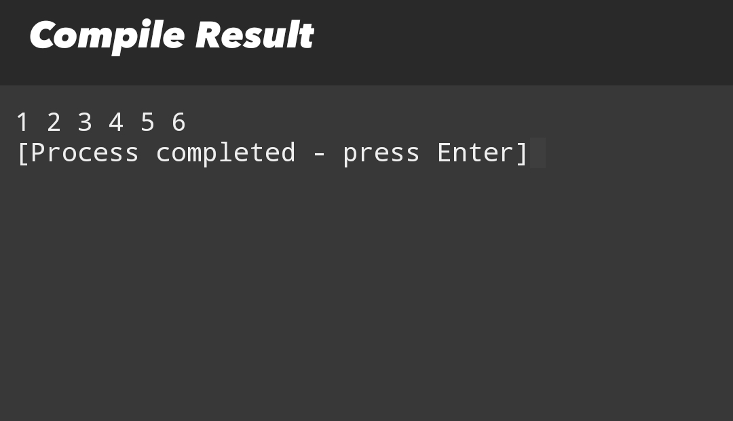

2. Find largest element in array

#include <stdio.h>

int Largest(int arr[], int size) {

int max = arr[0];

for (int i = 1; i < size; i++) {

if (arr[i] > max) {

max = arr[i];

}

}

return max;

}

int main() {

int arr[] = {10, 20, 5, 30, 15};

int size = sizeof(arr) / sizeof(arr[0]);

printf(”Largest element: %d\n”, Largest(arr, size));

return 0;

}

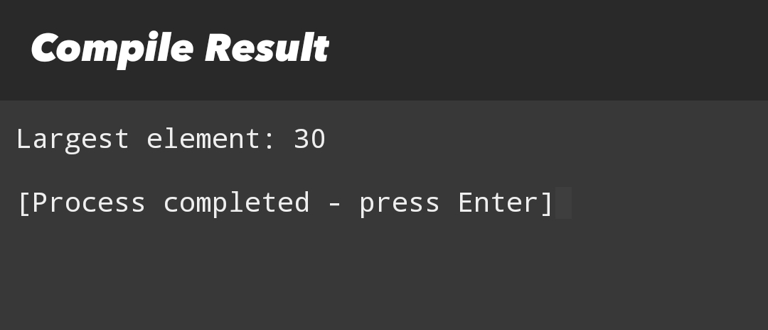

3. Find second largest element

#include <stdio.h>

int SecondLargest(int arr[], int size) {

int first = -1, second = -1;

for (int i = 0; i < size; i++) {

if (arr[i] > first) {

second = first;

first = arr[i];

} else if (arr[i] > second && arr[i] != first) {

second = arr[i];

}

}

return second;

}

int main() {

int arr[] = {10, 20, 5, 30, 15};

int size = sizeof(arr) / sizeof(arr[0]);

printf(”Second largest element: %d\n”, SecondLargest(arr, size));

return 0;

}

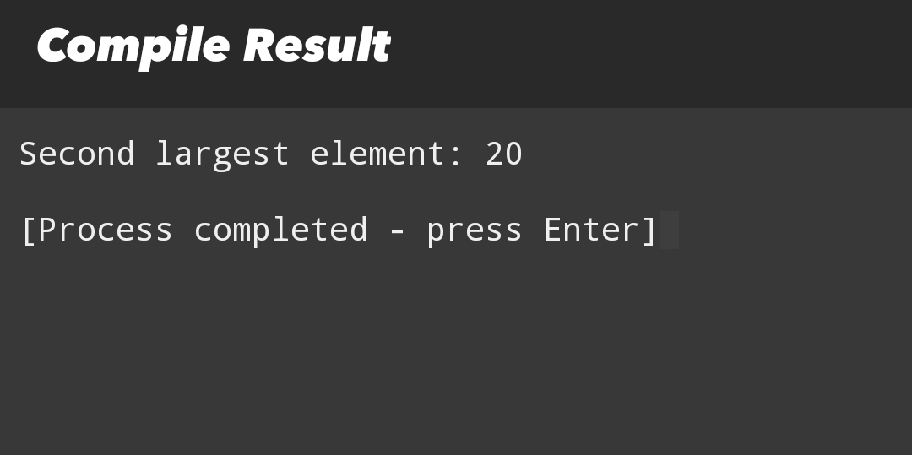

4. Move all zeros to end

#include <stdio.h>

void moveZeros(int arr[], int size) {

int count = 0;

for (int i = 0; i < size; i++) {

if (arr[i] != 0) {

arr[count++] = arr[i];

}

}

while (count < size) {

arr[count++] = 0;

}

}

int main() {

int arr[] = {0, 1, 0, 3, 12};

int size = sizeof(arr) / sizeof(arr[0]);

moveZeros(arr, size);

for (int i = 0; i < size; i++) {

printf(”%d “, arr[i]);

}

return 0;

}

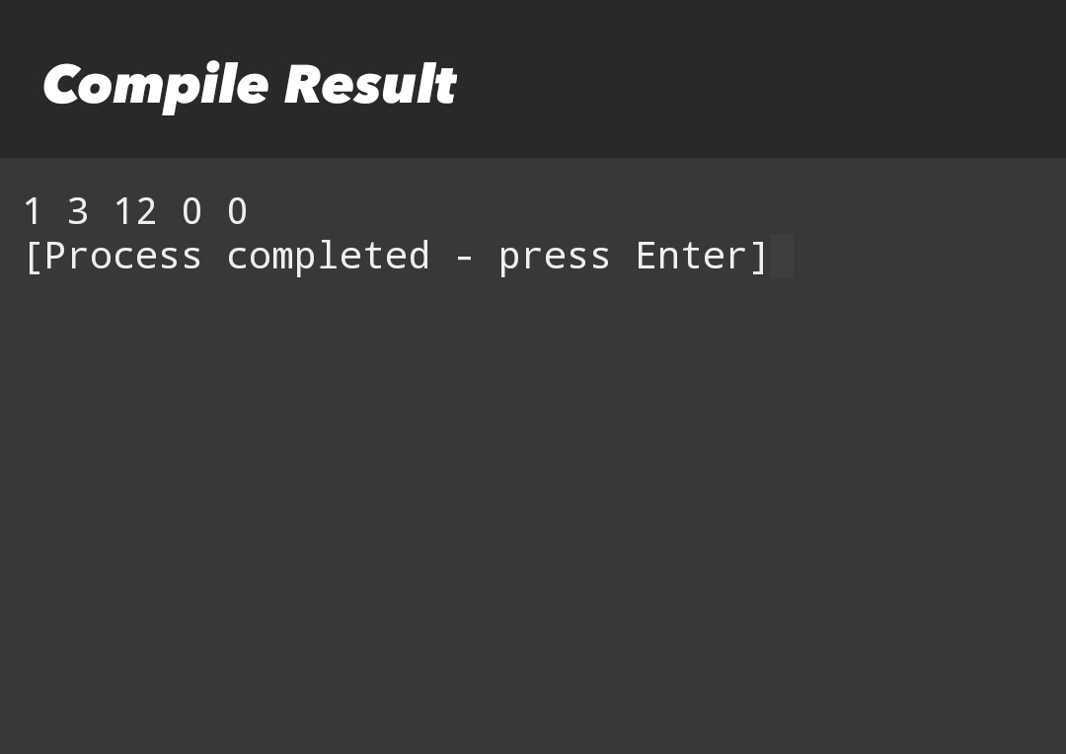

5. Rotate array by one

#include <stdio.h>

void rotateByOne(int arr[], int size) {

int temp = arr[size - 1];

for (int i = size - 1; i > 0; i--) {

arr[i] = arr[i - 1];

}

arr[0] = temp;

}

int main() {

int arr[] = {1, 2, 3, 4, 5};

int size = sizeof(arr) / sizeof(arr[0]);

rotateByOne(arr, size);

for (int i = 0; i < size; i++) {

printf(”%d “, arr[i]);

}

return 0;

}

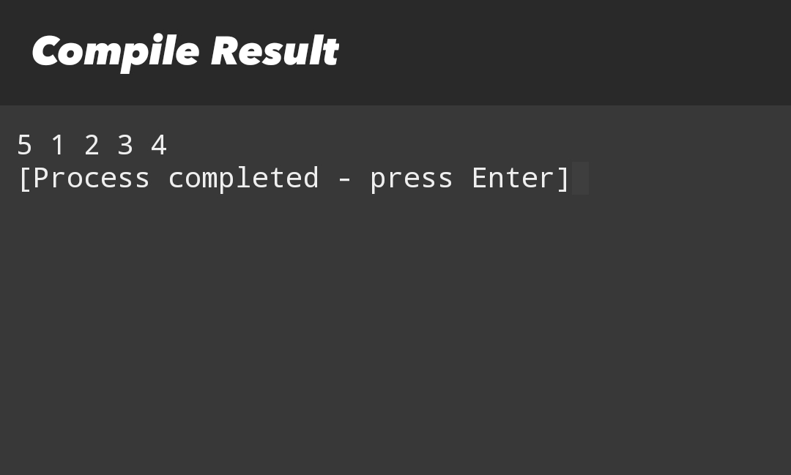

6. Check if array is sorted

#include <stdio.h>

#include <stdbool.h>

bool Sorted(int arr[], int size) {

for (int i = 0; i < size - 1; i++) {

if (arr[i] > arr[i + 1]) {

return false;

}

}

return true;

}

int main() {

int arr[] = {1, 2, 3, 4, 5};

int size = sizeof(arr) / sizeof(arr[0]);

printf(”Is sorted: %s\n”, Sorted(arr, size) ? “Yes” : “No”);

return 0;

}

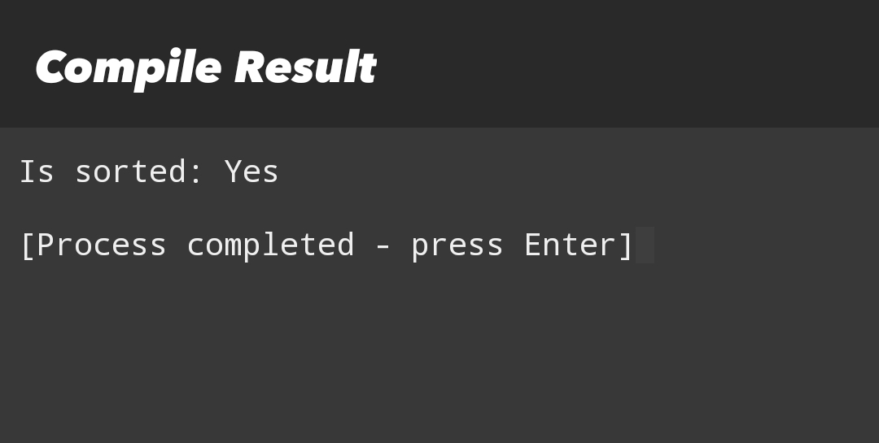

7. Reverse a string

#include <stdio.h>

#include <string.h>

void reverseString(char str[]) {

int n = strlen(str);

for (int i = 0; i < n / 2; i++) {

char temp = str[i];

str[i] = str[n - 1 - i];

str[n - 1 - i] = temp;

}

}

int main() {

char str[] = “Hello”;

reverseString(str);

printf(”Reversed string: %s\n”, str);

return 0;

}

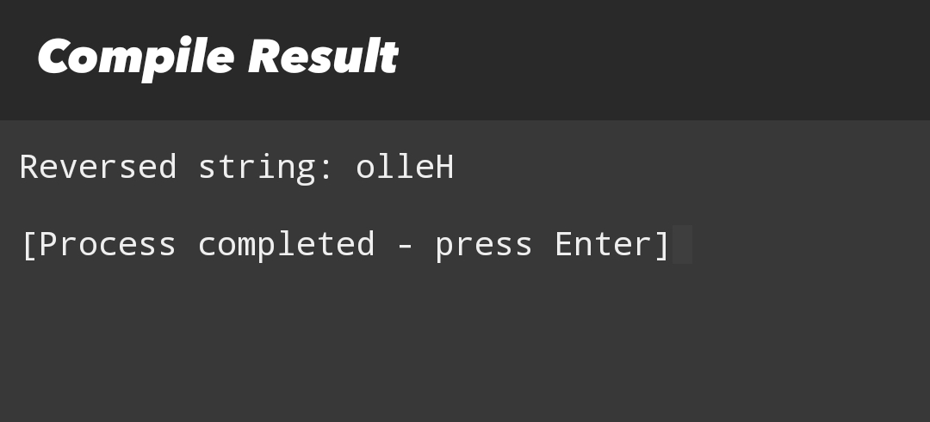

8. Check if string is palindrome

#include <stdio.h>

#include <string.h>

#include <stdbool.h>

bool Palindrome(char str[]) {

int left = 0;

int right = strlen(str) - 1;

while (left < right) {

if (str[left] != str[right]) {

return false;

}

left++;

right--;

}

return true;

}

int main() {

char str[] = “madam”;

printf(”Is palindrome: %s\n”, Palindrome(str) ? “Yes” : “No”);

return 0;

}

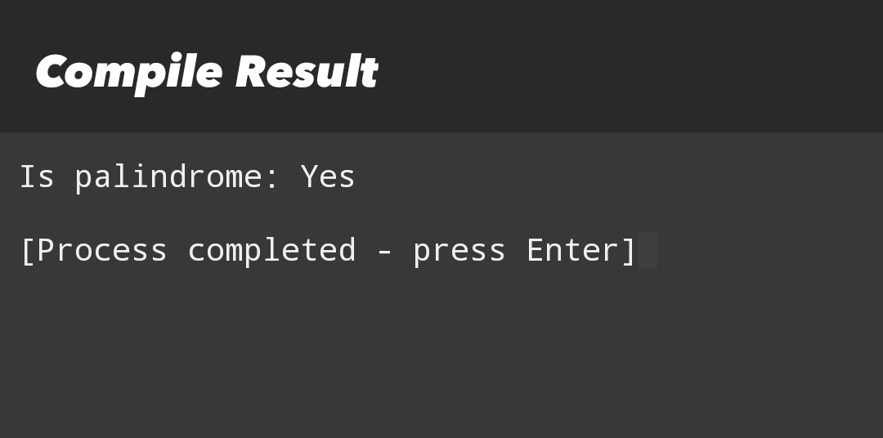

9. Count frequency of array elements

#include <stdio.h>

void countFrequency(int arr[], int size) {

for (int i = 0; i < size; i++) {

int count = 1;

if (arr[i] == -1) continue;

for (int j = i + 1; j < size; j++) {

if (arr[i] == arr[j]) {

count++;

arr[j] = -1;

}

}

printf("%d occurs %d times\n", arr[i], count);

}

}

int main() {

int arr[] = {1, 2, 3, 1, 2, 1};

int size = sizeof(arr) / sizeof(arr[0]);

countFrequency(arr, size);

return 0;

}

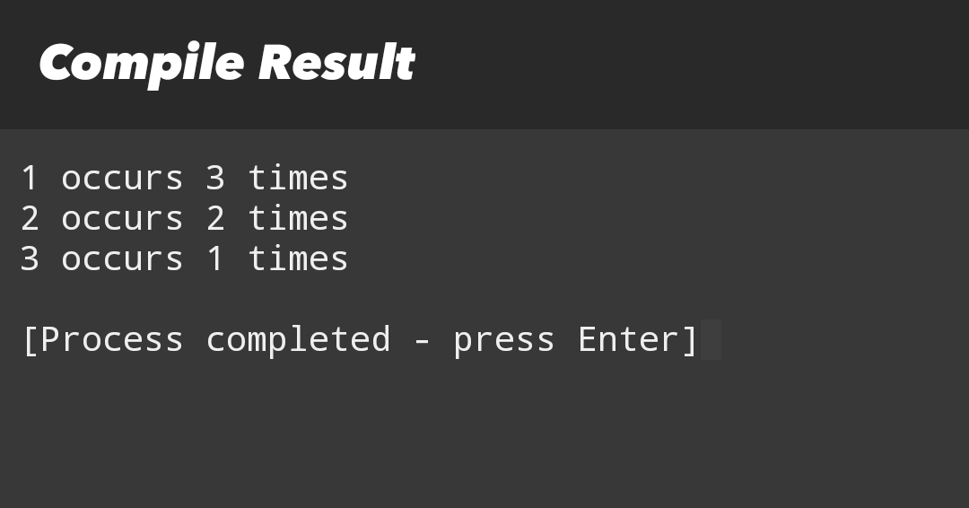

10. Reverse an array

#include <stdio.h>

void reverseArray(int arr[], int size) {

for (int i = 0; i < size / 2; i++) {

int temp = arr[i];

arr[i] = arr[size - 1 - i];

arr[size - 1 - i] = temp;

}

}

int main() {

int arr[] = {1, 2, 3, 4, 5};

int size = sizeof(arr) / sizeof(arr[0]);

reverseArray(arr, size);

printf(”{”);

for (int i = 0; i < size; i++) {

printf(”%d”, arr[i]);

if (i < size - 1) {

printf(”, “);

}

}

printf(”}\n”);

return 0;

}

